Postmortem Inspection Process

Cattle Inspection⚫

- Head Inspection

- Head Inspection
There are four steps in head inspection.
- Step one is to observe the outer surface of the head and eyes.
- Step two is to incise and observe the four pairs of lymph nodes – mandibular, parotid, lateral retropharyngeal (atlantal), and medial retropharyngeal (suprapharyngeal).
- Step three is to incise and observe the masticatory or cheek muscles.
- Step four is to observe and palpate the tongue.

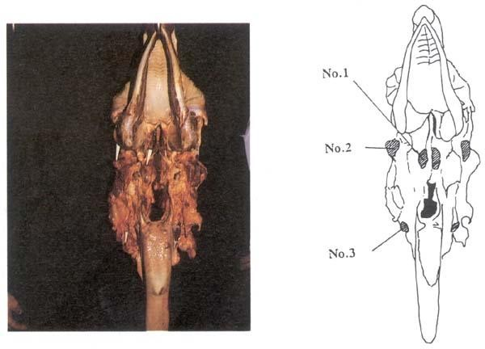

Fig.( 1) Head inspection.
Retropharyngeal (No. 1), parotid (No. 2) and sub maxillary (No. 3) lymph nodes are viewed and incised by multiple incisions and slicing

Conditions which you may see during head inspection

- Actinomycosis (lumpy jaw)

Is generally located in the bony structures of the head and jaws. It may be abscessed and is usually characterized by swelling. When the condition is localized, the head is usually condemned and the corresponding carcass will be retained, pending further inspection.

- Actinobacillosis (wooden tongue)
- Is generally located in the soft tissue of the head, such as the tongue and/or lymph nodes. The condition is frequently mistaken for an abscess and, if localized, part of the head may be salvaged after the removal of affected tissue. In some 0cases, this condition may be found in the viscera and lungs of the animal so the carcass is retained until after all inspection has been completed

- Epithelioma (cancer eye)
- Is the most common neoplasm of cattle. All breeds are susceptible, but Herefords cattle are by far the most commonly affected. The tumor originates in either the cornea , third eyelid, or the eyelids, and usually progresses to the surrounding bone and adjacent region. You would retain all heads and their corresponding carcasses when they exhibit any of these signs.

- Tuberculosis
- One of the primary reasons you incise lymph nodes is to detect TB. The affected lymph node involvement will vary from slightly involved to totall involved. When incised, the node affected usually exhibits a yellowish semi-liquid to caseous (cheese-like) mass of tissue interspersed with some normal tissue, greyish in color, and often showing signs of inflammation. When you detect what you suspect is TB, you must retain the head and corresponding carcass.

- Cysticercosis
- Is a condition in which larval cysts of the beef tapeworm Taenia saginata are found in the muscle tissue. The cyst is found chiefly in the muscles of the jaw, heart, and diaphragm. However, it may be found in other muscle tissue as well. A live cyst has the appearance of a pearl or fluid-filled sac.

- Eosinophilic Myositis (EM)
- lesions are most frequently detected (by observation) in the muscles of the cheeks, in the tongue, in the heart, and in the esophagus. They may invade other skeletal muscle tissue as well. The most common lesions are small, irregularly distributed, yellowish- green, yellowish, or greyish-white pin-head shaped spots

- Bruised Tissue
- Depending on the degree of bruised tissue, you will determine if the head should be condemned or trimmed by a company employee. You would not normally retain the carcass because of bruised tissue on the head.

